LAB#6

# NESTED LOOPS

Objective:

To understand and implement nested for loops and While loops.

**1.**LAB TASKS: Write a C++ program which prints the following pattern:

Source Code:

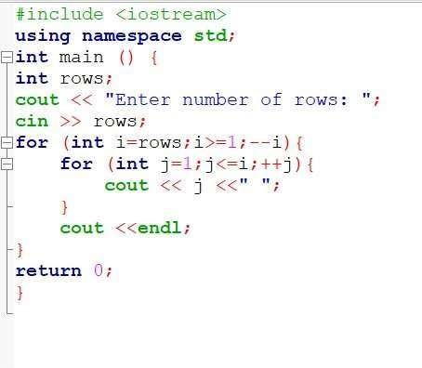

Output:

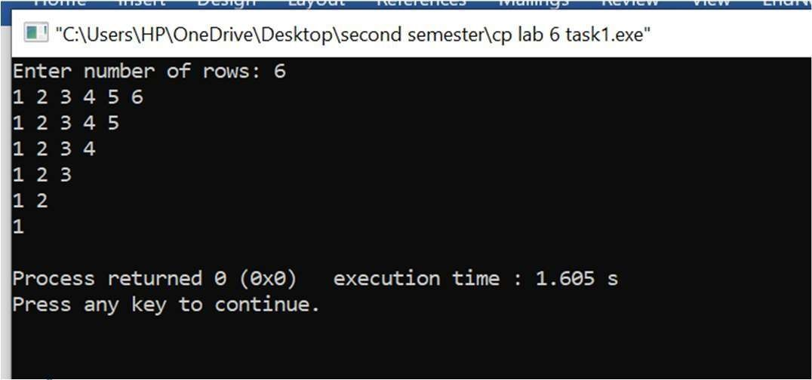

**2.**LAB TASKS: Write a C++ program which prints the following pattern:

Source Code:

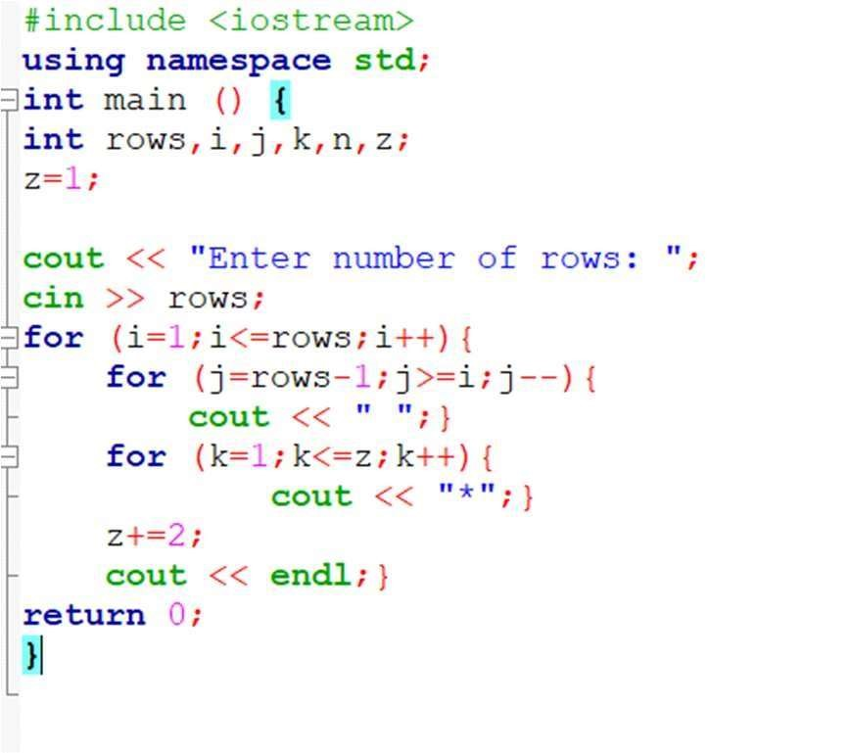

Output:

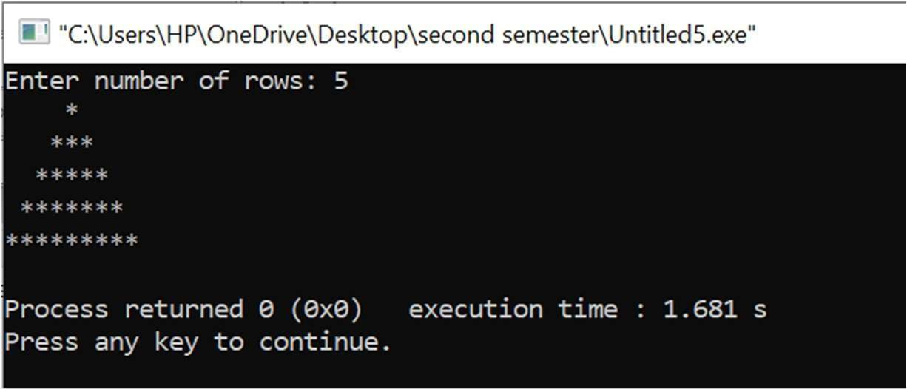

**3.**LAB TASKS: Write a C++ program which prints the following pattern:

Source Code:

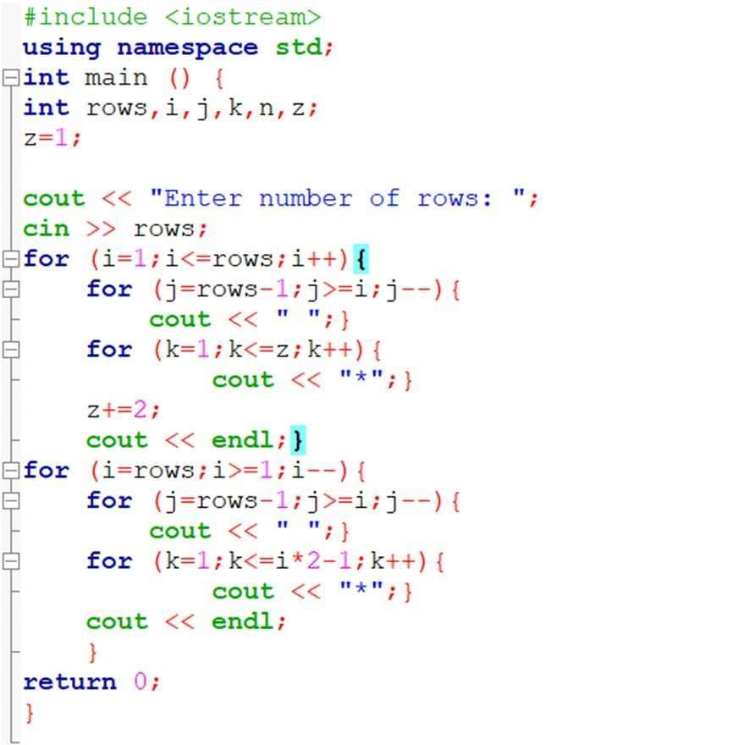

Output:

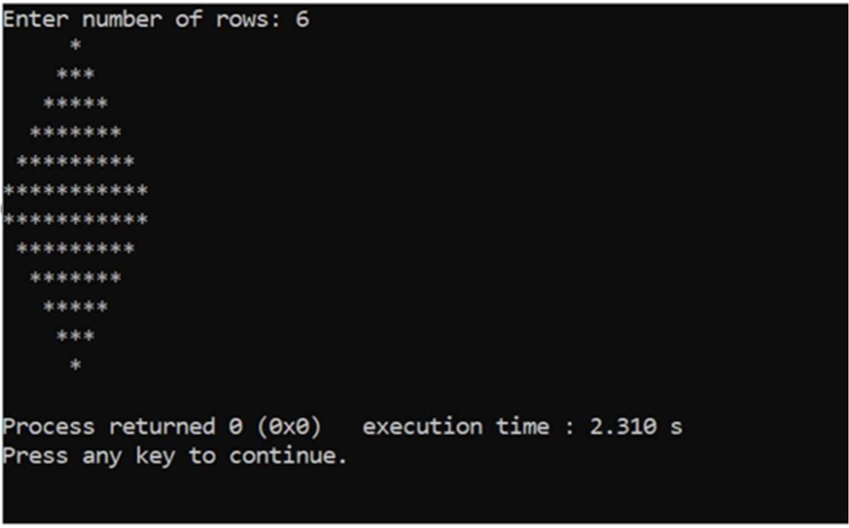

1. Implement the above example of break statement with the user input for number of weeks.

Source Code:

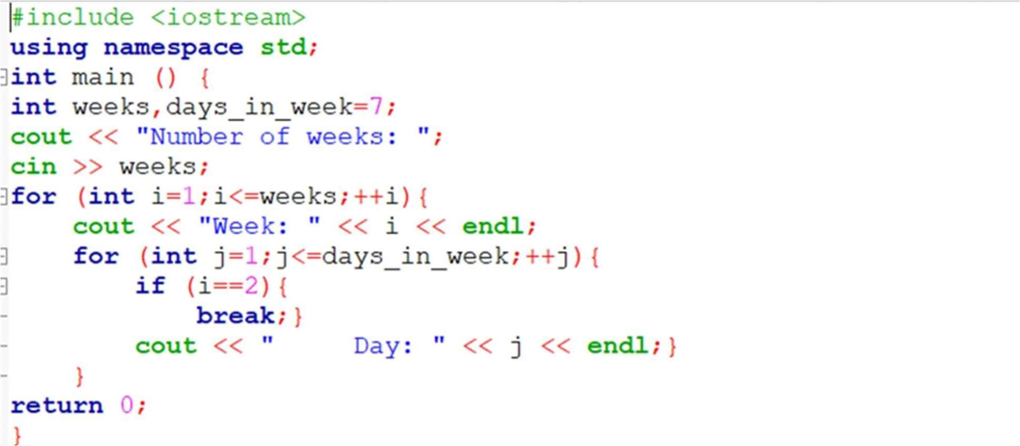

Output:

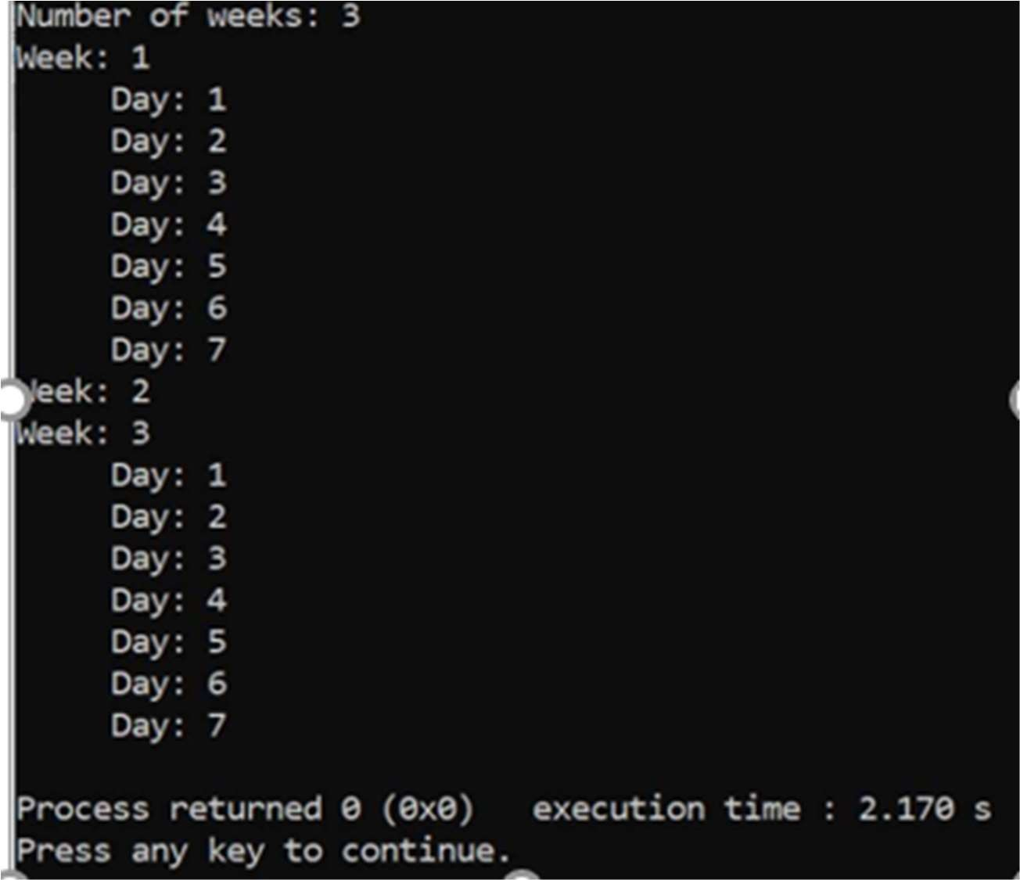

1. Implement the above example of continue statement which prints only odd numbers of the week.

Source Code:

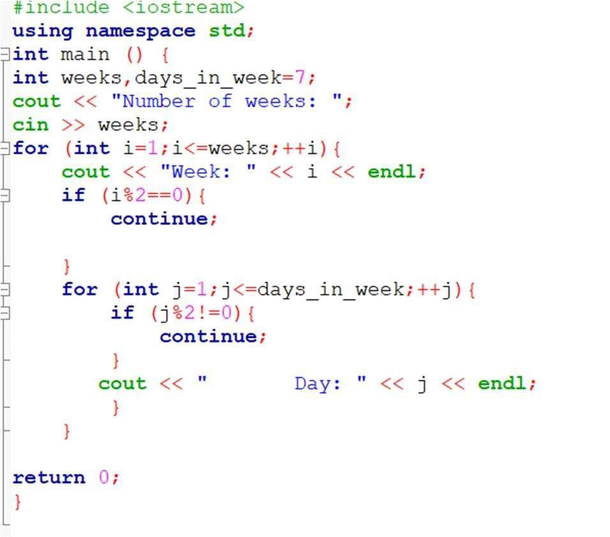

OUTPUT.

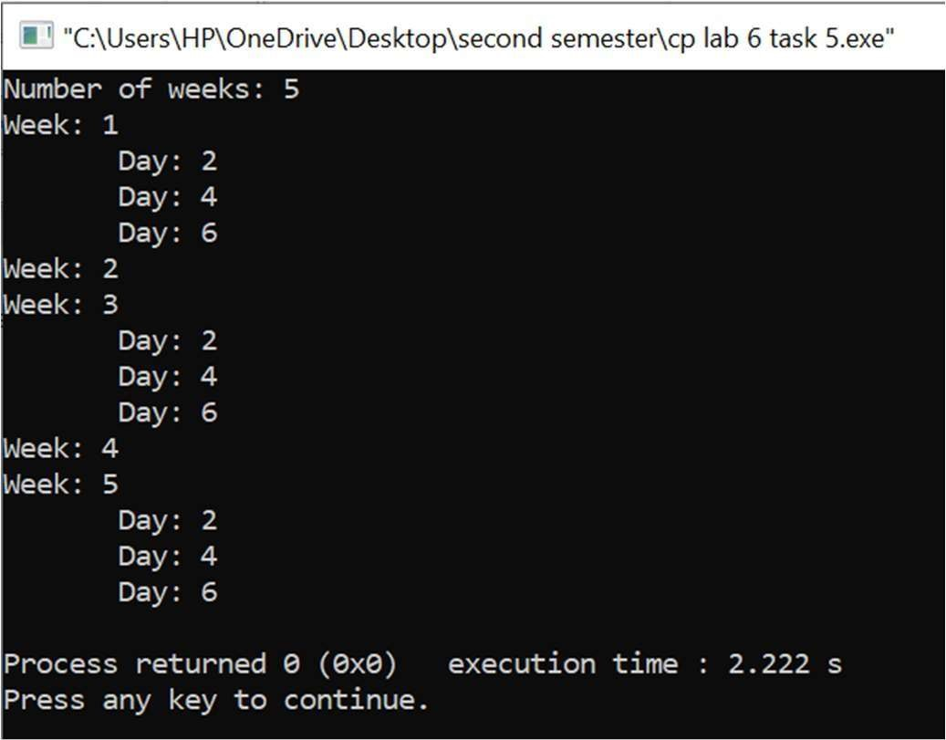

**6.**LAB TASKS: Write a C++ program which keeps calculating the sum the numbers entered by the user, but break if the user enters a prime number.

Source Code:

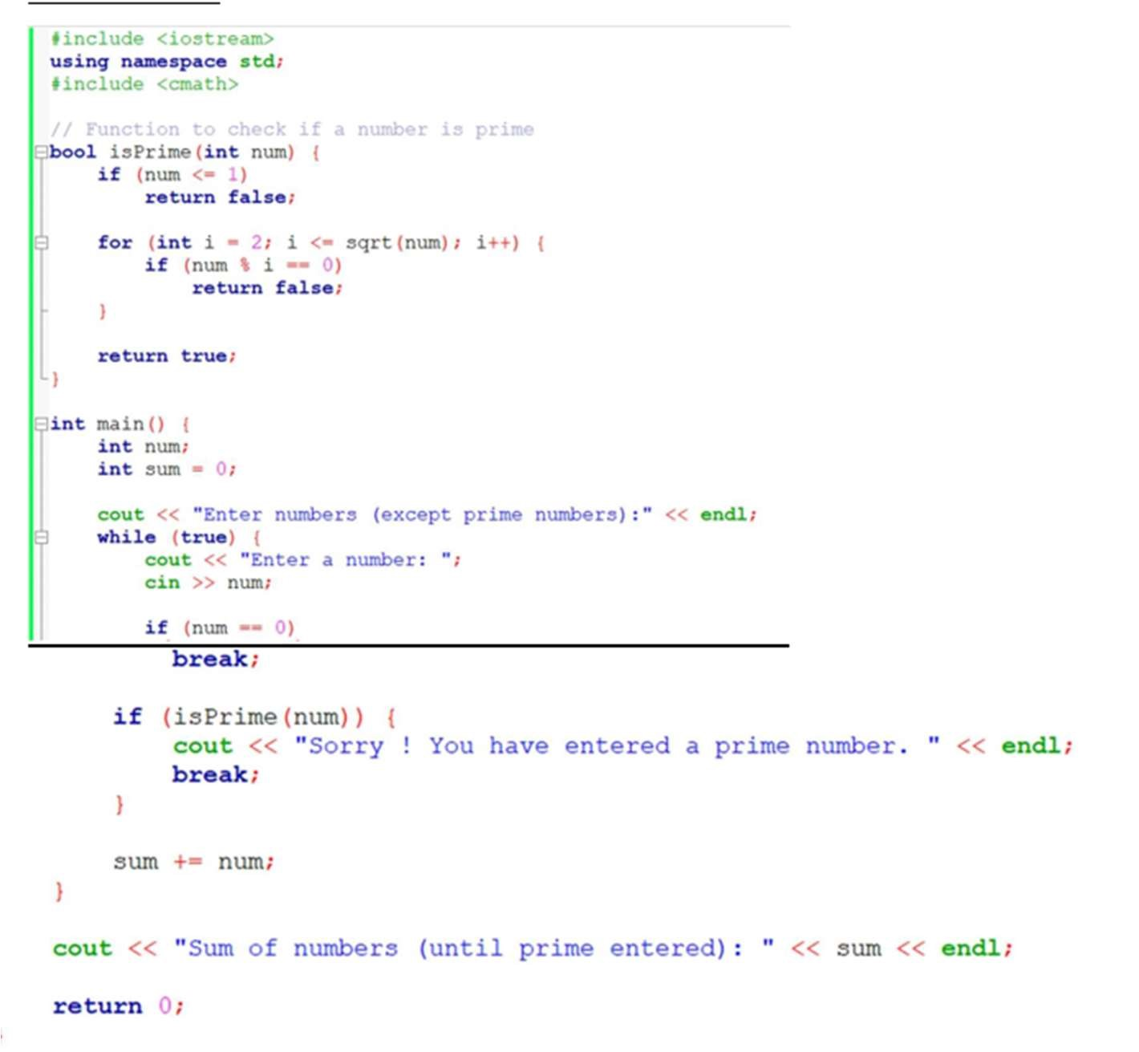

## OUTPUT;

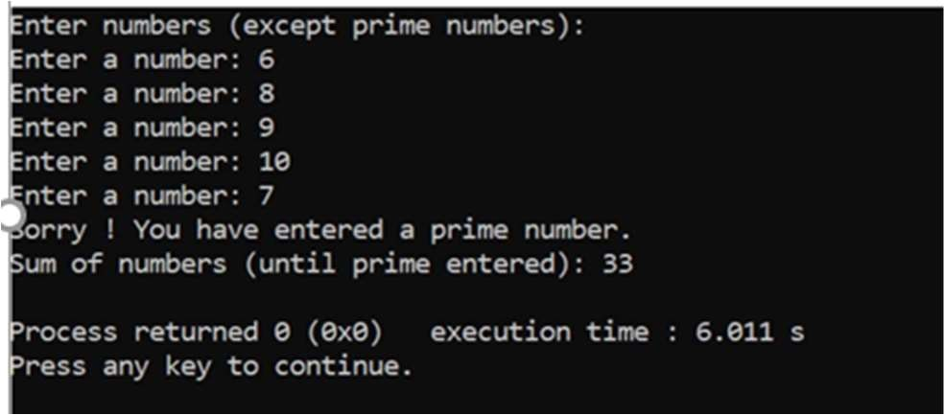

7. Write a C++ program which keeps calculating the sum of the numbers entered by the user, but should not add the number which is prime.

Source Code:

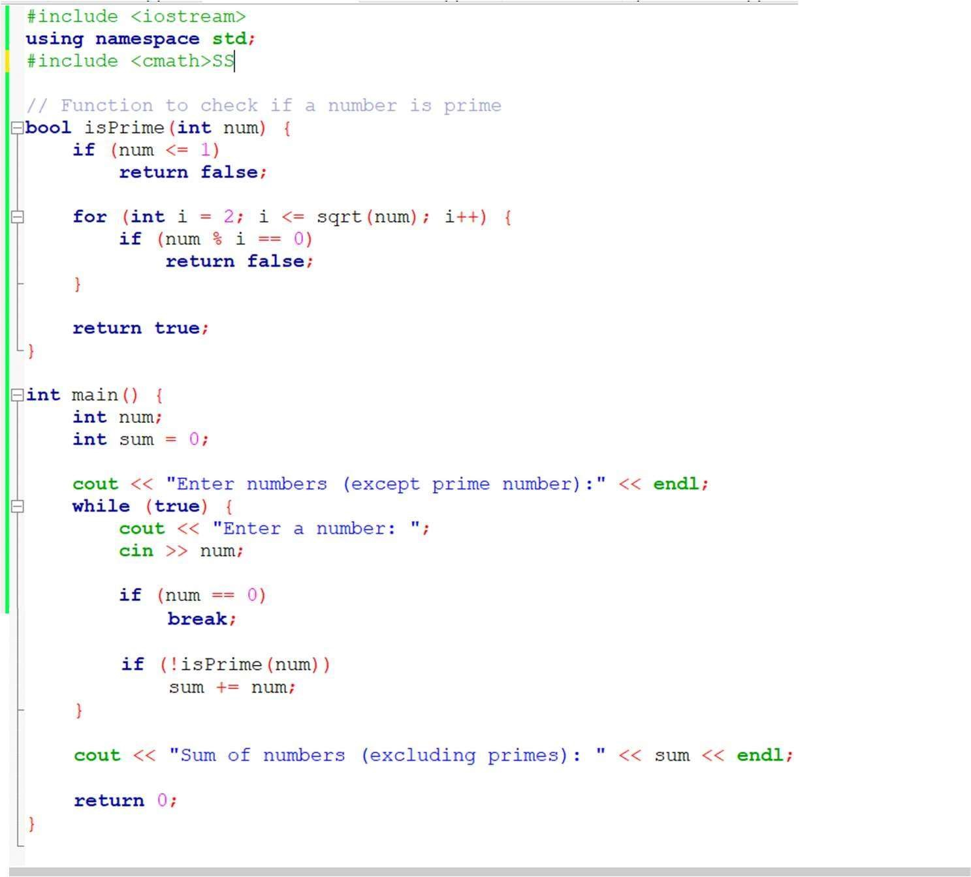

OUTPUT;

